Chatbot

Team Member:Nishanth Goud Pendimukulla-11514754

Github:<https://github.com/nishanthgoud06/chatBot>

. .

## Introduction:

To create a College Enquiry Chat Bot that gives users a keyboard interface via which they can write commands and get responses as text messages. It offers comprehensive state services and maintains the functionality and control flow of earlier instructions. Any platform, including the web and mobile devices, as well as channels like Skype, Slack, and Messenger, can simply integrate this. The chatbot serves as a 24/7 customer care representative and offers an effective method of information delivery utilizing artificial intelligence. The user's inquiries are examined to determine the proper intent and how it corresponds with the output message.

## Background:

in my undergrad, I have done a project in 3-Network intrusion detection using a supervised machine learning technique with feature selection. in which I have used TensorFlow to develop a neural network in chatbot I have used the same concept

<https://github.com/nishanthgoud06/Detector>

while doing this project I have followed the article mentioned below <https://chatbotsmagazine.com/contextual-chat-bots-with-tensorflow-4391749d0077>

## Your Model:

### Architecture Diagram:

in the below architecture diagram the user enters the query in our case, he will enter “does unt have bus rides” which goes into natural language processing which passes the message into the decision-making engine which sends a request to the Knowledge database where it sends the response back to the decision-making engine then the Decision-Making engine passes the response to message generator where the response is displayed to the user.

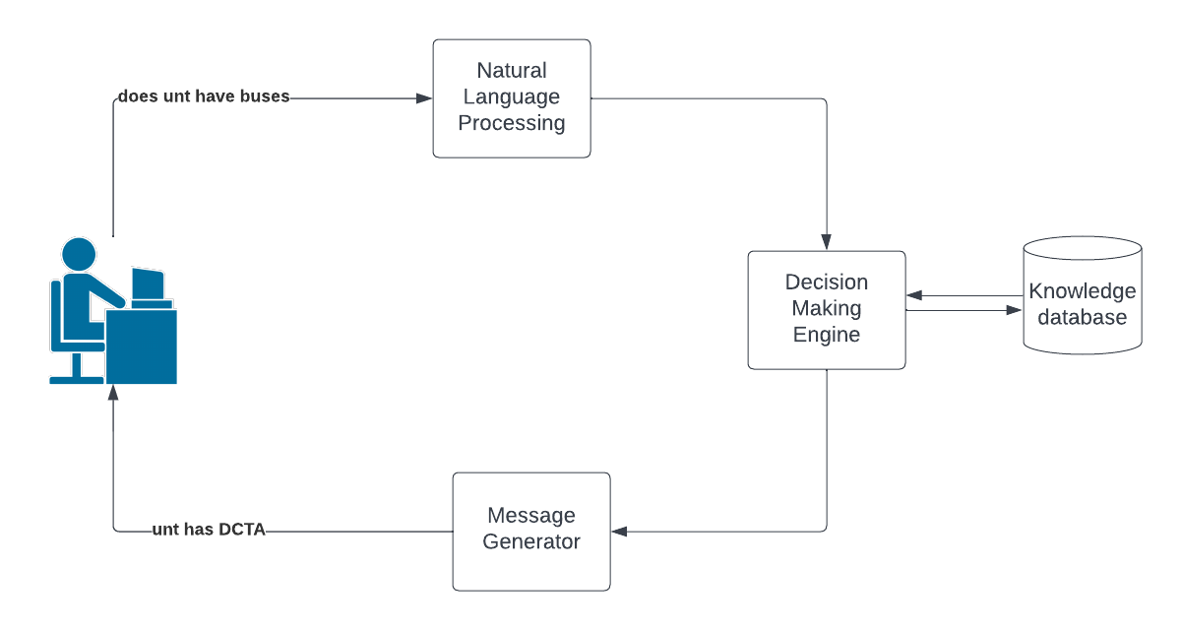

### 

### Workflow diagram:

the below workflow, diagram shows how a user query is evaluated a response is generated

There are various steps which a query processes through.

firstly, when the user enters the query then the conditional statement is reached where it checks whether the query matches the pattern which we have saved in the intent file. if yes it will give the response which is also saved in a JSON file a response. if it doesn’t match the pattern it will first remove any symbols if the user enters the query. then it checks for spelling errors. then it will check whether it matches any pattern. if not it will try to predict the most appropriate response. then it will display the response back to the user. the process ends.

## 

## 

## 

## Dataset:

### A detailed description of Dataset:

the data set is stored in JSON format which is saved in dictionary format key: value, here we have 3 different keys where the tag contains the context(if the query is wishing for example it comes under greeting there are many different tags which we have used in the dataset., the pattern has a value that the user might ask as a query if not as you can see in the workflow diagram it will clean and tries to match with the most accurate pattern and the response key where the algorithm is gonna respond with.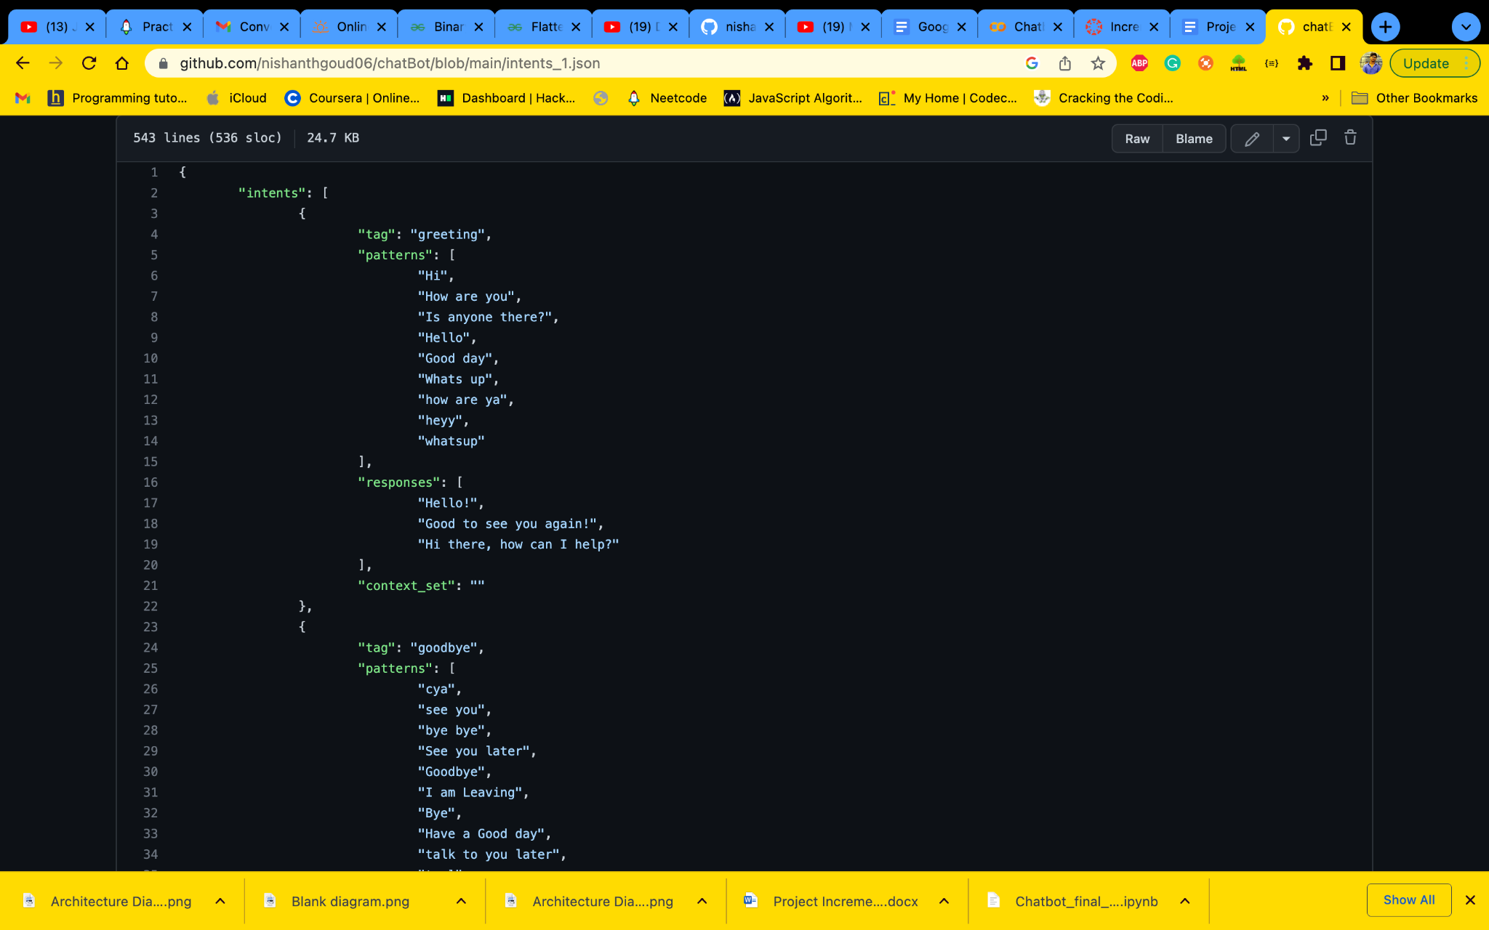

### Detail design of Features:

as you can see the execution starts when the user enters the query first the NLP will analyse the query where it begins by trying to match with the pattern if it can’t find it will reanalyze the query it will remove all unnecessary symbols and check for any spelling errors and identify the tag and display the response back to the user. we have a total of 283 Documents, 26 Classes and 193 Stemmed Words.

## 

## Analysis of data:

### Data Pre-processing:

to preprocess the data with NLP we are going to implement tokenisation, and remove stop words,puntuations and streaming

we begin the process by converting the list of words by removing all spaces and tabs. then we are going to remove all the unnecessary symbols from the token list. and lastly, we are gonna use the nltk stemmer class to go through the token which has been generated in the previous step and implement steam on each of the tokens.

### Graph model:

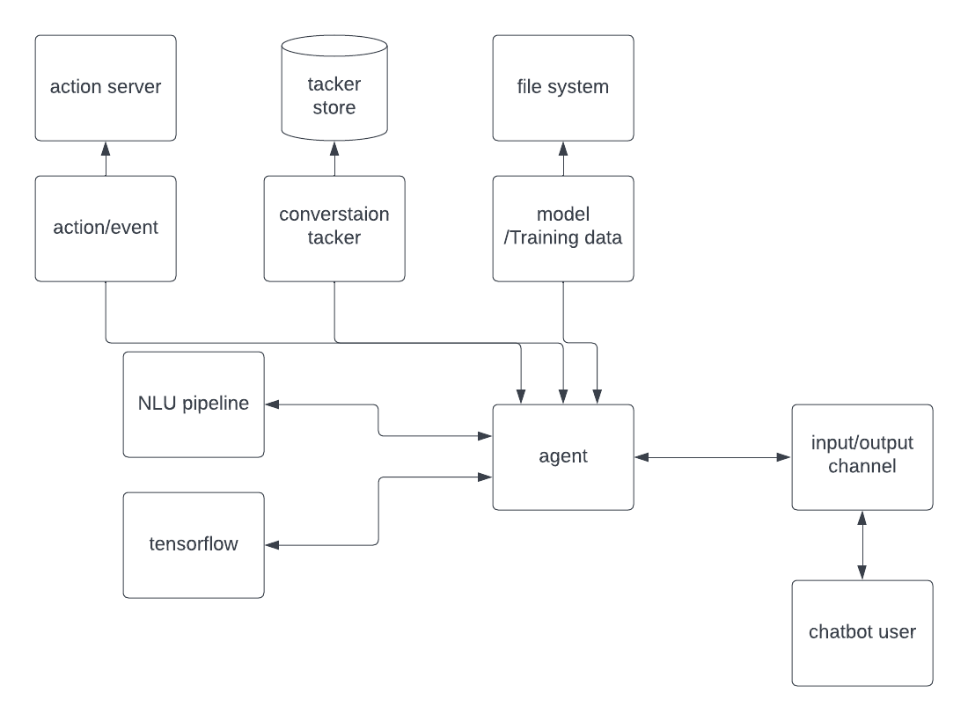

in this project, I have used knowledge graphs as it is one of the impressive databases that have been developed to take on the marketing of conversation. when we have decided to develop an application which involves constant communication with the client it is preferred to use the knowledge graphs

the two main components in our chat is first one being Natural Language processing and the second TensorFlow.

operations such as intents classification, entities extraction and response recovery are implemented by a pipeline of nlu.

Tensorflow is used for developing the neural network and it is also used to build the conversation according to the context.

## Implementation

### Algorithms/Pseudocode and explanation of implementation:

first, we are going the create the training data.in order to create the training data we need to create the glossary for all the words that we stored in the pattern in the intent file. then we need to create the list of the classes, and patterns which are within the JSON file as the associated tags which have all the other patterns in the JSON file.

#### 

as we have our data separated, the next step is to train the algorithm. for that, we are going to use TensorFlow to generate the neural network but first, we need to convert our data into values of numerical so that the neural network can be performed.

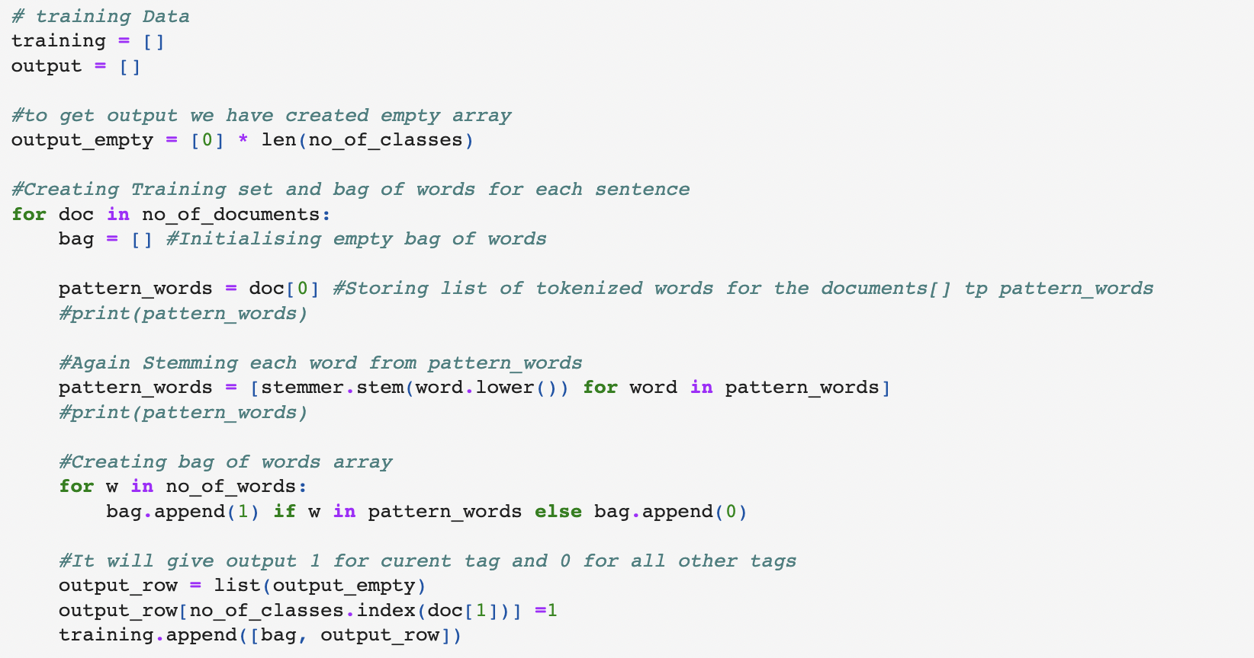

now as our data has been converted into numerical data we can use TensorFlow to generate the neural network

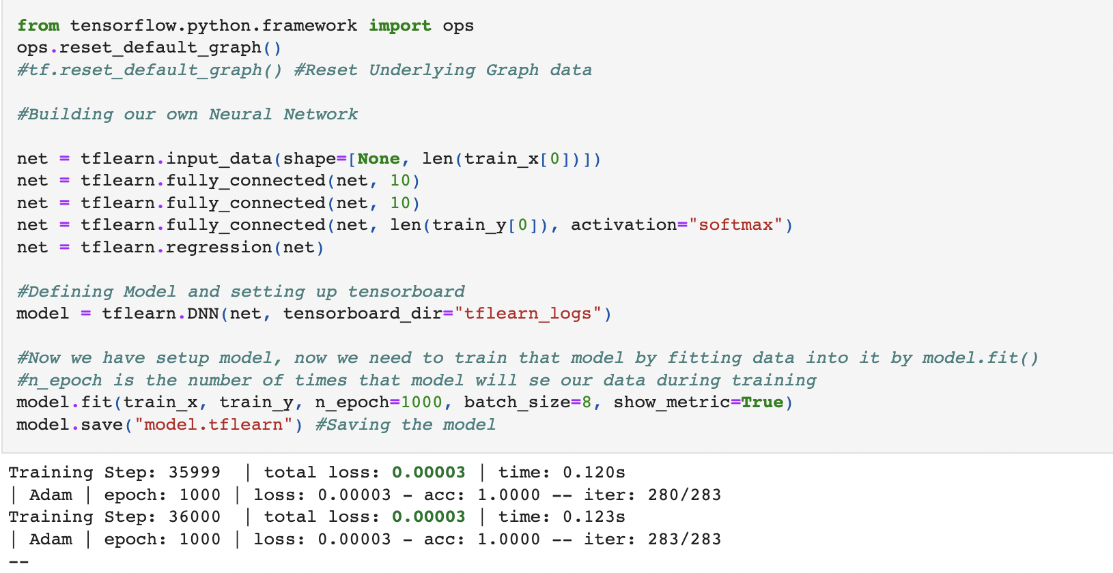

now we have our deep learning model now we have to develop an application where it can get the query from the user where the query needs to be tokenised and stemmed after that we need to add some context to the conversation for better results.

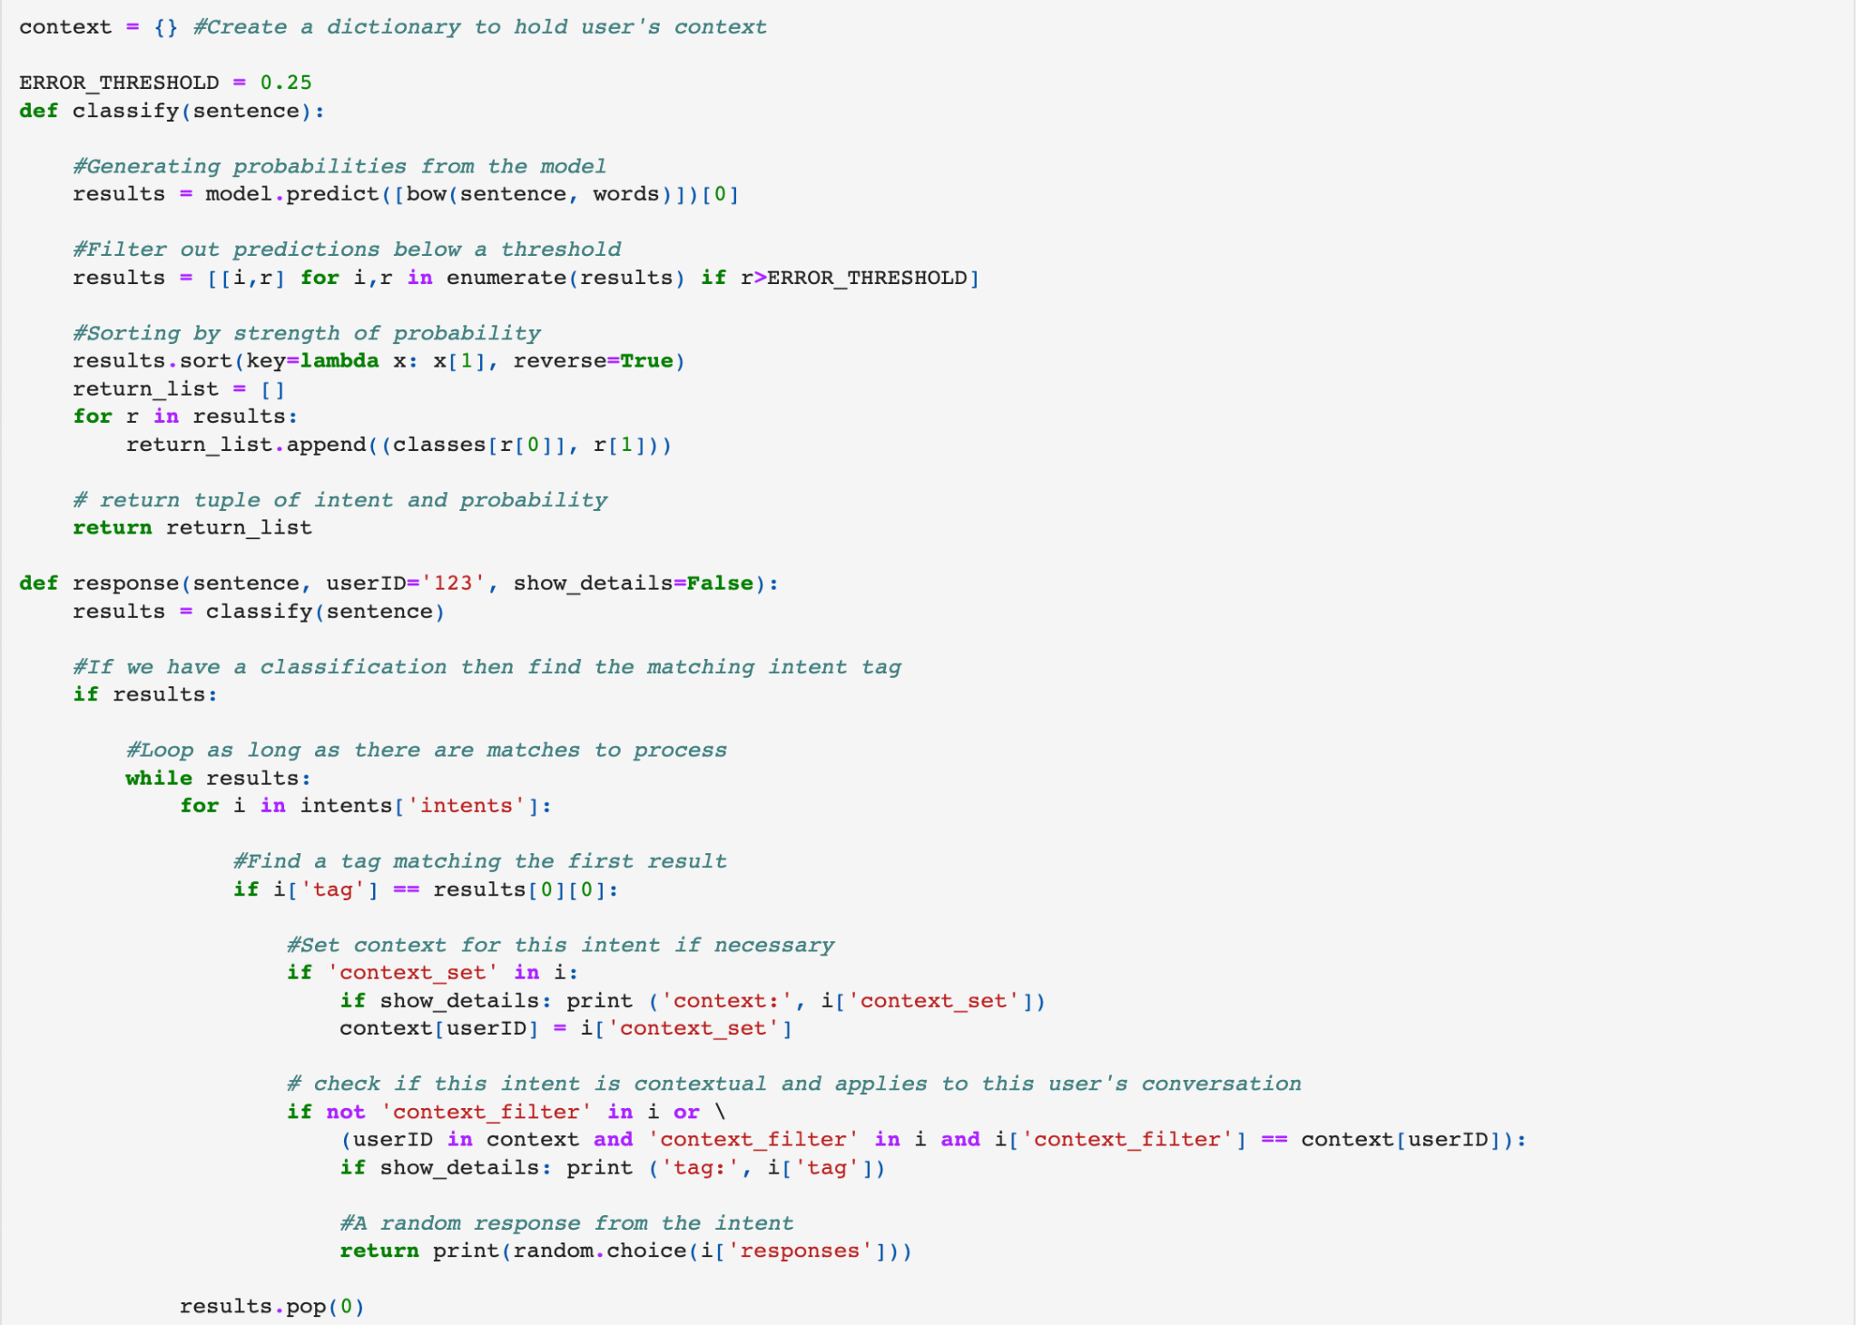

#### 

## Results:

## 

These are the results which we got as a response from the chatBot.we got accurate results for each of our queries.

## Project management:

### Implementation status report:

**Name**: Nishanth Goud Pendimukulla

**Responsibility**: creating the dataset, training the model, creating the neural network

**contribution**:100%

**concerns**: no concerns as this is an individual project

#### what has been changed from Increment-1

as I mentioned in increment 1 we need to add more data in the JSON format. The more data the better the response from the algorithm. now I have added more tags, patterns and responses, in addition, I have added links as all the information can’t be given as a response back to the user with the link so he can get more information about the enquiry he has. as you see in the results space that when the user asks the question of whether “unt has a bus ride” or not he gets the link along with the answer to the question.

## Reference:

Alepis, E., & Virvou, M. (2011). Automatic generation of emotions in tutoring agents for affective e-learning in medical education. Expert Systems with Applications, 38(8): 9840–9847.

Ashok, G., Brian, C., Mithun, K., Shanu, S., Abhinaya, S., & Bryan, W. (2015). Using Watson for Enhancing Human-Computer Co-Creativity. AAAI Symposium: 22–29.

Avalverde, D. (2019). A Brief History of Chatbots. Perception, Control, Cognition. Retrieved March 9, 2019, from: [https://pcc.cs.byu.edu/2018/03/26/a-brief-history-of-chatbots/](https://www.google.com/url?q=https%3A%2F%2Fpcc.cs.byu.edu%2F2018%2F03%2F26%2Fa-brief-history-of-chatbots%2F&sa=D&sntz=1&usg=AOvVaw35Eko-ZvjVSDGKzCqCYeCX)

Ayedoun, E., Hayashi, Y., & Seta, K. (2015). A Conversational Ageno Encourage Willingness to Communicate in the Context of English as a Foreign Language. Procedia Computer Science, 60(1): 1433–1442.

Ben Mimoun, Mohammed Slim, & Poncin, I. (2015). A valued agent: How ECAs affect website customers' satisfaction and anbehavioursrs. Journal of Retailing and Consumer Services, 26: 70– 82.

Chatbot Magazine (2019). A Visual History of Chatbots. Retrieved March 9, 20,19 from: [https://chatbotsmagazine.com/a-visual-history-of-chatbots-8bf3b31dbfb2](https://www.google.com/url?q=https%3A%2F%2Fchatbotsmagazine.com%2Fa-visual-history-of-chatbots-8bf3b31dbfb2&sa=D&sntz=1&usg=AOvVaw348XQu7kw_PZMselCnkUmo)

Colace, F., De Santo, M., Lombardi, M., Pascale, L., Pietrosanto, A. (2018). Chatbot for E-Learning: A Cases Study. International Journal of Mechanical Engineering and Robotics Research Vol. 7, No. 5, September.

Egencia (2018). What is a Chatbot and How does it work? Retrieved March 9, 20,19 from: <https://www.youtube.com/watch?v=38sL6pADCog>

Hattie, J. (2012). Visible learning for teachers: Maximizing impact on learning: Routledge. [https://chatbotsmagazine.com/a-visual-history-of-chatbots-8bf3b31dbfb2](https://www.google.com/url?q=https%3A%2F%2Fchatbotsmagazine.com%2Fa-visual-history-of-chatbots-8bf3b31dbfb2&sa=D&sntz=1&usg=AOvVaw348XQu7kw_PZMselCnkUmo)

Lip ko, H. (2018). Meet Jill Watson: Georgia Tech's first AI teaching assistant. Retrieved on March 9, 20,19 from: [https://pe.gatech.edu/blog/meet-jill-watson-georgia-techs-first-ai-teaching-assistant](https://www.google.com/url?q=https%3A%2F%2Fpe.gatech.edu%2Fblog%2Fmeet-jill-watson-georgia-techs-first-ai-teaching-assistant&sa=D&sntz=1&usg=AOvVaw0PtCZ9_cPkBtkHRT1nLGbh).

Maruti Techlabs. (2018). Why can chatbots replace Mobile Apps immediately? Retrieved March 9, 20,19 from: [https://www.marutitech.com/why-can-chatbots-replace-mobile-apps-immediately/](https://www.google.com/url?q=https%3A%2F%2Fwww.marutitech.com%2Fwhy-can-chatbots-replace-mobile-apps-immediately%2F&sa=D&sntz=1&usg=AOvVaw1HL8N9pYWXUcIrzgnBJdRn)

[Nguyen](https://www.google.com/url?q=https%3A%2F%2Fwww.businessinsider.com%2Fauthor%2Fmai-hanh-nguyen&sa=D&sntz=1&usg=AOvVaw0u1T5Ilc4EosCDTg4b4z6i), M. (2017). How artificial intelligence & machine learning produced robots we can talk to. Business Insider. Retrieved March 9, 20,19 from: [https://www.businessinsider.com/what-is-chatbot-talking-ai-robot-chat-simulators-2017-10](https://www.google.com/url?q=https%3A%2F%2Fwww.businessinsider.com%2Fwhat-is-chatbot-talking-ai-robot-chat-simulators-2017-10&sa=D&sntz=1&usg=AOvVaw38ei-h_0y94DMrnf-iIiHB)

Simplilearn (2018). Machine Learning Basics. Retrieved March 9, 2019 from: <https://www.youtube.com/watch?v=ukzFI9rgwfU>

Sproutsocial.com (2018). A complete Guide to Chatbots in 2018. Retrieved March 9, 2019 from: [https://sproutsocial.com/insights/topics/chatbots/](https://www.google.com/url?q=https%3A%2F%2Fsproutsocial.com%2Finsights%2Ftopics%2Fchatbots%2F&sa=D&sntz=1&usg=AOvVaw3QXWJnNk-p4lvPdv3nj_7m)

V Soft Consulting. (2019). 7 of the best Language-learning Chatbot Apps. Retrieved March 9, 2019 from: [https://blog.vsoftconsulting.com/blog/7-of-the-best-language-learning-chatbot-apps](https://www.google.com/url?q=https%3A%2F%2Fblog.vsoftconsulting.com%2Fblog%2F7-of-the-best-language-learning-chatbot-apps&sa=D&sntz=1&usg=AOvVaw1gU7rzUVpv1hJC2kLV_wRz)

Wikipedia (2019). Chatbot. Retrieved March 9, 2019 from: [https://en.wikipedia.org/wiki/Chatbot](https://www.google.com/url?q=https%3A%2F%2Fen.wikipedia.org%2Fwiki%2FChatbot&sa=D&sntz=1&usg=AOvVaw1tYncuuYzEzANmVTmo2Q1f)

Wikipedia (2019). Siri. Retrieved March 9, 2019 from: [https://en.wikipedia.org/wiki/Siri#Features_and_options](https://www.google.com/url?q=https%3A%2F%2Fen.wikipedia.org%2Fwiki%2FSiri%23Features_and_options&sa=D&sntz=1&usg=AOvVaw3Jeop_dA0RyNdr9Es96wYN)

Winkler, R., Söllner, M. (2018): Unleashing the Potential of Chatbots in Education: A State-Of-The-Art Analysis. In: Academy of Management Annual Meeting (AOM). Chicago, USA.